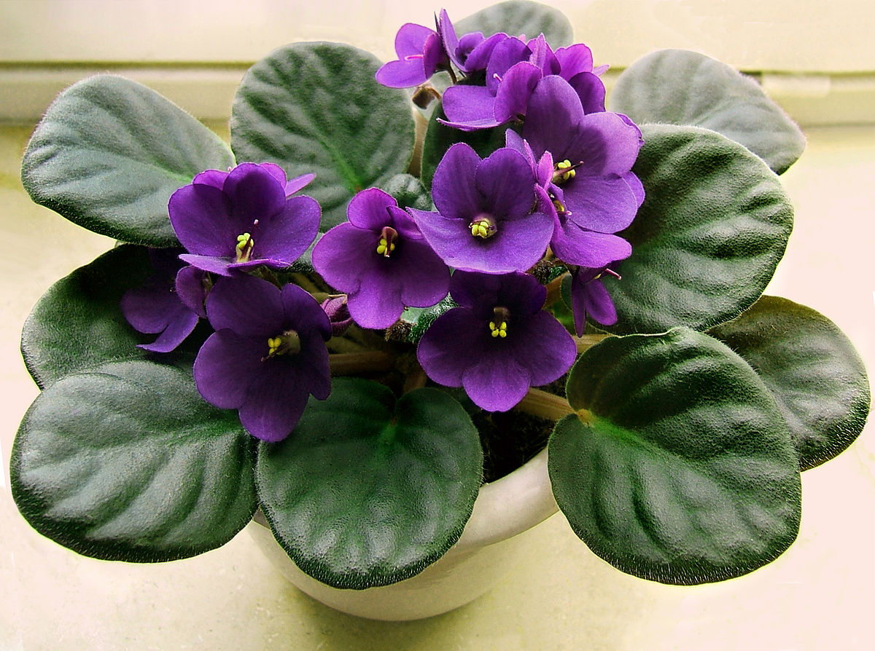

**African Violet**

*Saintpaulia ionantha*

(<https://upload.wikimedia.org/wikipedia/commons/thumb/1/19/2007-04-20Saintpaulia_ionantha04.jpg/1200px-2007-04-20Saintpaulia_ionantha04.jpg>)

**Size/Type:**

Large Standard

**Height:**

under 6 in. (15 cm)

**Bloom Color:**

Blue-Violet

**Flower Characteristics:**

Single

**Leaf Shape/Type:**

Pointed

Spooned

Quilted

Serrated

**Leaf Texture:**

Glossy/shiny

**Leaf Color:**

Red Back (or red reverse)

Dark

**Patent Information:**

Non-patented

**Propagation:**

May be propagated by seed

May be propagated by cuttings (leaf, sucker, or bloom stalk)

**Soil pH requirements:**

6.1 to 6.5 (mildly acidic)

6.6 to 7.5 (neutral)

**Water Requirements:**

Average Water Needs; Water regularly; do not overwater

**Where to Grow:**

Suitable for growing in containers

This plant is suitable for growing indoors